**Experiment 02**

**Learning Objective**:

Student should be able to develop a calculator (Addition and Subtraction) for a 16 bits number using macros and procedure. (Menu Based).

**Tools:** TASM/MASM

**Theory:**

Definition of Macro:

The assembly language programmer often finds certain statements being repeated in the program. The programmer can take the advantage of ‘MACRO’ facility where MACRO is defined to be –**Single line abbreviation for group of instructions.**

The template to be followed for defining a MACRO is as follows:

**MACRO Start of Definition**

**Macro Name**

**Macro Body**

**MEND END of Macro definition**

**Definition & function of Macro processor:**

* Macro processor is a program which is responsible for processing the macro.
* There are four basic tasks/ functions that any macro instruction processor must perform.

1. **Recognize macro definition:**
   1. A macro instruction processor must recognize macro definitions identified by the MACRO and MEND pseudo-ops.
2. **Save the definitions**:
   1. The processor must store the macro instruction definitions, which it will need for expanding macro calls.
3. **Recognize calls:**
   1. The processor must recognize macro calls that appear as operation mnemonics. This suggests that macro names be handled as a type of opcode.
4. **Expand calls and substitute arguments:**
   1. The processor must substitute for dummy or macro definition arguments the corresponding arguments from a macro call; the resulting symbolic (in this case, assembly language) text is then substituted for the macro call. This text, of course, may contain additional macro definitions or calls.
   2. In summary: the macro processor must recognize and process macro definitions and macro calls.

The template to be followed for defining a **Procedure** is as follows:

**PROC Proc_name Start of Definition**

**RET**

**Proc_name ENDP END of procedure**

|  |  |  |  |
| --- | --- | --- | --- |
| MACROS | | PROCEDURE / Subroutine | |
| 1 | The corresponding machine code is written every time a macro is called in a program. | 1 | The Corresponding m/c code is written only once in memory |
| 2 | Program takes up more memory space. | 2 | Program takes up comparatively less memory space. |
| 3 | No transfer of program counter. | 3 | Transferring of program counter is required. |
| 4 | No overhead of using stack for transferring control. | 4 | Overhead of using stack for transferring control. |
| 5 | Execution is fast | 5 | Execution is comparatively slow. |
| 6 | Assembly time is more. | 6 | Assembly time is comparatively less. |
| 7 | More advantageous to the programs when repeated group of instruction is too short. | 7 | More advantageous to the programs when repeated group of instructions is quite large. |

**Application:**

Use of Macros and procedure in the Assembly Language programming to write modular program.

**Design:**

**Result and Discussion:**

.model small

.stack

.data

M1 DB 10,13,"Addition is : $"

M2 DB 10,13,"Subtraction is :$"

NO1 DW 4536H

NO2 DW 2312H

RES DW ?

.code

DISP MACRO XX

MOV AH,09

LEA DX,XX

INT 21H

ENDM

.startup

DISP M1

MOV AX,NO1

ADD AX,NO2

MOV RES,AX

CALL DISP1

DISP M2

MOV AX,NO1

SUB AX,NO2

MOV RES,AX

CALL DISP1

JMP LAST

DISP1 PROC

MOV BX,RES

AND BH,0F0H

MOV CL,4

SHR BH,CL

ADD BH,30H

MOV DL,BH

MOV AH,02

INT 21H ;first digit display ends here

MOV BX,RES

AND BH,0FH

ADD BH,30H

MOV DL,BH

MOV AH,02

INT 21H ;second digit display ends here

MOV BX,RES

AND BL,0F0H

MOV CL,4

SHR BL,CL

ADD BL,30H

MOV DL,BL

MOV AH,02

INT 21H ;third digit display ends here

MOV BX,RES

AND BL,0FH

ADD BL,30H

MOV DL,BL

MOV AH,02

INT 21H ;fourth digit display ends here

RET

DISP1 ENDP

LAST:

.exit

end

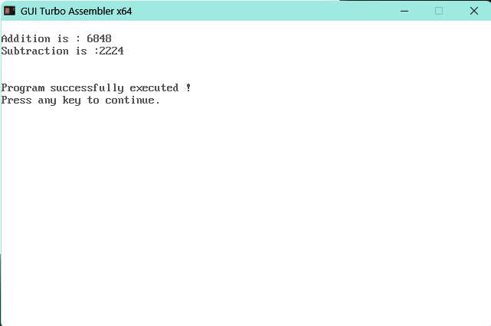

**Learning Outcomes:**

The student should have the ability to

LO1: Explain how to use macros and procedure in the program.

LO2: Compare Macro and procedure.

LO3: Apply macros and procedure to implement the program.

**Course Outcomes**:

Upon completion of the course students will be able to make use of instructions of 8086 to build assembly and Mixed language programs.

**Conclusion:**

For Faculty Use

|  |  |  |  |  |
| --- | --- | --- | --- | --- |
| **Correction Parameters** | **Formative Assessment [40%]** | **Timely completion of Practical**  **[ 40%]** | **Attendance / Learning Attitude [20%]** |  |
| **Marks Obtained** |  |  |  |